

Controlling Harmful Algae Blooms
Harmful Algae Blooms (HAB) such as Cyanobacteria (blue-green algae) represents a nuisance in water where excess nutrients and growing conditions exist. HAB’s can excrete hazardous toxins and produce toxins that create drinking water problems, limit use of beaches, create fish kills and odors that affect residents and visitors. The result places economic burdens on communities. This is a serious problem nationally and over 60 percent of freshwater bodies are impaired, affecting some 80,000 miles of rivers and streams and 2.5 million acres of lakes, reservoirs, and ponds, and coastal seawater.
Long term, key nutrients need to be lowered, such as phosphorus (P) and nitrates (N), but this can take years. In the interim, water quality treatments can minimize the effects of HAB. It is known that HAB can be controlled using bacillus and other bacteria; however, such treatment requires multiple treatments that are not practical for larger water bodies. MetaMateria’s Bio-Lair and PO4 Sponge products are especially effective in reducing nutrients needed to support HAB. PO4 Sponge removes more reactive phosphorus than other products and Bio-Lair sustains high bacteria levels that break down existing algae blooms and keep them from reforming.
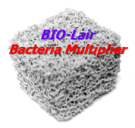
Bio-Lair is a porous ceramic product with exceptionally high amounts of surface for bacteria reproduction. It has 100 times more surface than plastic products. This allows large populations of bacteria to develop that are 5 times higher than normal and these will out-compete algae for nutrients. Blooms break down and do not reform.
Bioremediation is widely used in nature and in waste treatment systems to remove organics, N, and even biologically tie up soluble P. A key to using Bio-Lair for HAB control is selecting the right combination of beneficial bacteria with high bacterial count for a quick start-up.
Bacteria are known to help control algae blooms and break down organics in bottom sediments. High concentrations of enzymatic bacillus and pseudomonas bacteria are effective in breaking down existing blooms. Bacillus bacteria naturally form in soils and there are thousands of strains. While useful in controlling HAB, bacteria suppliers require repeated treatments throughout the algae growing season, sometimes as often as every 2 weeks. While this may be feasible for smaller ponds; it is costly and repeated treatment is impractical for larger water bodies. New bacteria have to be added regularly because the surfaces for colonization are largely on the bottom sediment, not up in the water where it is needed for HAB control. Bacillus bacteria will reduce sediment thickness (sometimes by12 inches/year).
Bio-Lair is packaged in nets and can be located up in the water where it becomes an ideal substrate for reproduction of beneficial bacteria needed to maintain higher concentrations up in the water. This reduces a need for regular bacteria additions. HAB breaks down and does not reform, as long as the nutrients remain controlled.
MetaMateria’s Bio-Lair sustains high concentrations of the beneficial bacteria that have been used effectively with commercial bacteria blends that cost less than comparable products on the market high concentrations of colonizable bacteria that begin working quickly. To better understand the power provided by this combination of the right bacteria blend and Bio-Lair, it is helpful to examine how these unique products work together.
While many bacteria products exist, there are significant differences between the type and quantity of active colonizable bacteria available. Bacteria are one of the oldest life forms on earth and are present in virtually every environment. In fact, the number of beneficial bacteria far outweighs the number of harmful strains, such as the HAB cyanobacteria. Bacteria are absolutely essential to the natural recycling of nutrients throughout the environment and they biologically maintain healthy water by breaking down nitrogen, carbon, and other contaminants and can even biologically incorporate some soluble P. This is nature’s way of controlling contaminants, and for a normal environment, existing bacteria are enough to do the job; however, when excess contaminants exist, such as proteins, oils or unhealthy bacteria, or when oxygen is too low, water quality suffers and supplemental bacteria can provide the extra help needed, especially when blends of bacteria can handle a broad array of contaminants, allowing water to be cleaned faster.
BIO-Lair represents a bacteria factory that constantly creates new bacteria on the enormous surface available. A fog of bacteria is swept into surrounding water and high concentrations needed to control HAB can be maintained. Depending upon the conditions, the bacteria lower nutrients in the water and breaks down organics to keep the water clear.
Amazing results occur when BIO-Lair is used with the right blend of beneficial bacteria
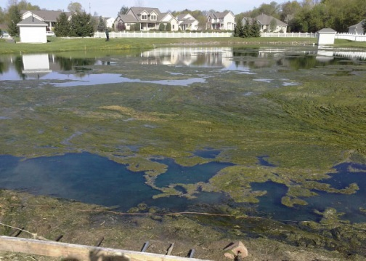
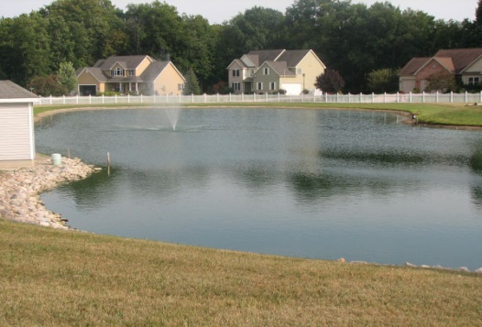
The pictures below show how effective this approach can be for HAB control. This community holding pond contained high phosphorus from a septic treatment system. Thick algae blooms formed each summer, creating an unsightly and smelly problem. Once treated, algae disappeared in weeks and never reformed. New bacteria treatment is done each Spring when the water warms.

AFTER TREATMENT

BEFORE TREATMENT

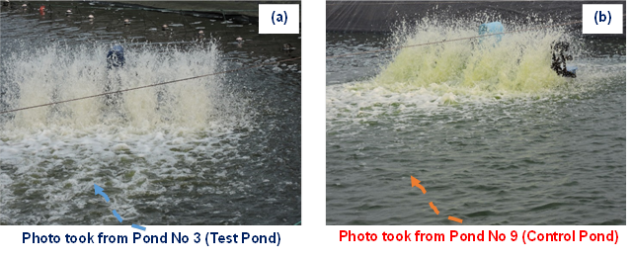
Similar results in controlling algae are found in treatment of fish and shrimp ponds where nutrient levels are particularly high. Bio-Lair used with bacillus bacteria was able to control algae blooms in aquaculture ponds with no repeat additions of bacteria needed. The pictures below show paddlewheel aerators kicking up water. The Test pond water with media is white (and clear) while water in Control pond is green in color (algae) and is not clear.

MetaMateria is interested in working with interested organizations for deployment of Bio-Lair and bacteria to control HAB in other water bodies. Economics of treatment depend upon the specific application but are much less than chemicals. The cost per acre depends upon the application but is expected to range from $50 to $120/acre.

For more information:
Dr. J. Richard Schorr, CEO
jrschorr@metamateria.com • 614-599-0939 (mobile)

